**Paper Sketch to digital wireframe using**

# Machine Learning

*(* Bachelor of Technology Degree in Computer Science & Engineering)

*Submitted by*

**Himanshu Dangwal**

**Bhumika Chuphal**

**Ismita Negi**

**Abhishek Rana**

**Under the guidance of**

*Mr. Purshottam Dass*

*Assistant Professor (GEHU)*



**DEPARTMENTOFCOMPUTERSCIENCEANDENGINEERING GRAPHIC ERA HILL UNIVERSITY**

**May, 2023**

# CERTIFICATE

This is to certify that the thesis titled **“ Paper Sketch to Digital Wireframe using Machine Learning” submitted** by **Himanshu Dangwal, Bhumika Chuphal, Ismita Negi, Abhishek Rana**, to Graphic Era Hill University for the award of the degree of **Bachelor of Technology**, is a bona fide record of the research work done by him/her under our supervision. The contents of this project in full or in parts have not been submitted to any other Institute or University for the award of any degree or diploma.

**Mrs. Rishika Yadav** Project Guide

(Assistant Professor)

GEHU,Dehradun Place: Dehradun

Date: 10-May-2023

# TABLEOFCONTENTS

**SNO. TITLE PAGE NO.**

1. **INTRODUCTION 1**
2. **REQUIREMENTS 2**
   1. Hardware Requirements
   2. Software Requirements
3. **BLOCK DIAGRAM 3**
4. **METHODOLOGY 4-8**
   1. Algorithm
   2. Implementation
      1. Data Gathering
      2. Data Management
      3. Model Learning
      4. Detection of UI

4.2.4 Wireframe Code Generation

4.2.4 Evaluation

1. **WORKFLOW DIAGRAM 9-10**
2. **RESULT 11**
3. **APPLICATIONS AND FUTURE WORK 11**
4. **CONCLUSION 12**
5. **REFERENCES 13**

## ACKNOWLEDGMENT

We would like to express our gratitude to The Almighty Shiva , the most Beneficent and the most Merciful, for completion of project.We would like to thank particularly our project Mentor Mr. Purushottam Das for his patience, support and encouragement throughout the completion of this project and having faith in us.

At last but not the least we greatly indebted to all other persons who directly or indirectly helped us during this work.

Mr. Himanshu Dangwal(1918377)

Mrs. Bhumika Chuphal(1918300)

Mrs. Ismita Negi(1918393)

Mr Abhishek Rana(1918127)

## CHAPTER 1 INTRODUCTION

* 1. ABOUT PROJECT

User interface (UI) design is a critical aspect of developing digital products and applications. It involves creating visually appealing and user-friendly interfaces that facilitate efficient interactions and positive user experiences. Traditionally, UI designers would begin the design process by sketching initial concepts and layouts on paper. However, this manual approach often presented challenges in terms of time consumption, accuracy, and the ability to iterate and collaborate effectively.

With the rapid advancements in deep learning and computer vision techniques, there has been a paradigm shift in various domains, including image recognition, natural language processing, and generative modelling. These advancements offer significant potential to revolutionize the UI design process by automating certain tasks and streamlining the overall workflow. One such task that can benefit from deep learning is the conversion of hand-drawn paper sketches into digital wireframes, which serve as the foundational blueprint for UI design.

The primary motivation behind this project is to explore the application of deep learning algorithms for automating the conversion of paper sketches to digital wireframes. By harnessing the power of deep learning models, we aim to develop a comprehensive framework that can accurately analyze and interpret hand-drawn sketches, providing a seamless transition from the physical medium to the digital realm. This approach has the potential to significantly enhance the efficiency and effectiveness of the UI design process, enabling designers to iterate rapidly and collaborate more seamlessly with other stakeholders.

## REQUIREMENTS

2.1 HARDWARE REQUIREMNTS

Sufficient computing power to train deep learning models, such as GPUs or cloud-based computing resources.

* Sufficient storage to store the dataset and trained models.
* **Device name :** DESKTOP-CFPLD5T
* **Processor** : Intel(R) Core(TM) i5-6200U CPU @ 2.30GHz 2.40 GHz
* **RAM :** 8.00 GB
* **System Type :** 64-bit operating system, x64-based processor

2.2 SOFTWARE REQUIREMENTS

Deep learning libraries and frameworks, such as TensorFlow or PyTorch, to design and train the models.

Preprocessing and cleaning tools to prepare the collected data for machine learning.

User interface development tools to create a user-friendly interface for designers to input their hand-drawn sketches.

* **Operating System :** Windows 10
* **Language used :** Python
* **IDE used :** PyCharm (2019.2.3), jupyter Notebook
* **Libraries used :** Pandas, NumPy, Pickle, OpenCV, Tensorflow, Keras
* **For GUI :** HTML, CSS, ReactJs

**BLOCK DIAGRAM**

|  |  |  |  |  |  |  |  |  |
| --- | --- | --- | --- | --- | --- | --- | --- | --- |
| |  | | --- | | Input Image | | Preprocessing | | | | | |  | | --- | | Segmentation | |
|  |
| |  | | --- | | Digital prototype | | | |  | |  | | --- | | Training  Model | | |  | | --- | | Splitting data into training & testing | | | |
|  | | |
|  | | |
|  | |  | | --- | | Building Model | | |
| |  | | --- | | Classification | | | |

Fig1. Block Diagram for Easy Sketch

1. **Machine Learning**

Machine learning is the study of computer algorithms that improve automatically through experience and using data. It is seen as a part of artificial intelligence.

Let us try to understand Machine Learning in layman’s term. Consider you are trying to toss a paper into a dustbin. After the first attempt, you realize that you have put too much force into it. After the second attempt, you realize you are closer to the target, but you need to increase your throw angle. What is happening here is after every throw we are learning something and improving the result. We are programmed to learn from our experience.

**Machine learning** (**ML**) is a field devoted to understanding and building methods that let machines "learn" – that is, methods that leverage data to improve computer performance on some set of tasks.

Machine learning algorithms build a model based on sample data, known as training data, in order to make predictions or decisions without being explicitly programmed to do so. Machine learning algorithms are used in a wide variety of applications, such as in medicine, email filtering, speech recognition, agriculture, and computer vision, where it is difficult or unfeasible to develop conventional algorithms to perform the needed tasks.

A subset of machine learning is closely related to computational statistics, which focuses on making predictions using computers, but not all machine learning is statistical learning. The study of mathematical optimization delivers methods, theory and application domains to machine learning. Data mining is a related field of study, focusing on exploratory data analysis through unsupervised learning.

Some implementations of machine learning use data and neural networks in a way that mimics the working of a biological brain.

In its application across business problems, machine learning is also referred to as predictive analytics.

The term machine learning was coined in 1959 by Arthur Samuel, an IBM employee and pioneer in computer gaming and artificial intelligence. The synonym self*-*teachingcomputers was also used in this time period.

By the early 1960s an experimental "learning machine" with punched tape memory, called Cybertron, had been developed by Raytheon Company to analyze sonar signals, electrocardiograms, and speech patterns using rudimentary reinforcement learning. It was repetitively "trained" by a human operator/teacher to recognize patterns and equipped with a "goof" button to cause it to re-evaluate incorrect decisions. A representative book on research into machine learning during the 1960s was Nilsson's book on Learning Machines, dealing mostly with machine learning for pattern classification. Interest related to pattern recognition continued into the 1970s, as described by Duda and Hart in 1973. In 1981 a report was given on using teaching strategies so that a neural network learns to recognize 40 characters from a computer terminal.

Tom M. Mitchell provided a widely quoted, more formal definition of the algorithms studied in the machine learning field: "A computer program is said to learn from experience E with respect to some class of tasks T and performance measure P if its performance at tasks in T, as measured by P, improves with experience E." This definition of the tasks in which machine learning is concerned offers a fundamentally operational definition rather than defining the field in cognitive terms. This follows Alan Turing’s proposal in his paper "Computing Machinery and Intelligence", in which the question "Can machines think?" is replaced with the question "Can machines do what we can do?".

Modern-day machine learning has two objectives, one is to classify data based on models which have been developed, the other purpose is to make predictions for future outcomes based on these models. A hypothetical algorithm specific to classifying data may use computer vision of moles coupled with supervised learning to train it to classify the cancerous moles. A machine learning algorithm for stock trading may inform the trader of future potential predictions.

**The Three Types of Machine Learning Algorithms**

**Supervised learning:** Supervised learning, also known as supervised machine learning, is a subcategory of machine learning and artificial intelligence. It is defined by its use of labelled datasets to train algorithms that classify data or predict outcomes accurately.

In Supervised Learning, the machine learns under supervision. It contains a model that can predict with a labeled dataset. A labeled dataset is one where you already know the target answer.

In this case, we have images that are labeled a spoon or a knife. This known data is fed to the machine, which analyzes and learns the association of these images based on its features such as shape, size, sharpness, etc. Now when a new image is fed to the machine without any label, the machine is able to predict accurately that it is a spoon with the help of the past data.

Supervised learning can be further divided into two types:

* Classification
* Regression

1. Classification - Supervised Learning

Classification is used when the output variable is categorical i.e. with 2 or more classes. For example, yes or no, male or female, true or false, etc. In order to predict whether a mail is spam or not, we need to first teach the machine what a spam mail is. This is done based on a lot of spam filters - reviewing the content of the mail, reviewing the mail header, and then searching if it contains any false information. Certain keywords and blacklist filters that blackmails are used from already blacklisted spammers.

All these features are used to score the mail and give it a spam score. The lower the total spam score of the email, the more likely that it is not a scam.

Based on the content, label, and the spam score of the new incoming mail, the algorithm decides whether it should land in the inbox or spam folder.

2.   Regression - Supervised Learning 

Regression is used when the output variable is a real or continuous value. In this case, there is a relationship between two or more variables i.e., a change in one variable is associated with a change in the other variable. For example, salary based on work experience or weight based on height, etc. Let’s consider two variables - humidity and temperature. Here, ‘temperature’ is the independent variable and ‘humidity' is the dependent variable. If the temperature increases, then the humidity decreases.

These two variables are fed to the model and the machine learns the relationship between them. After the machine is trained, it can easily predict the humidity based on the given temperature.

**Unsupervised learning:** It is a machine learning technique in which the users do not need to    supervise the model. Instead, it allows the model to work on its own to discover patterns and information that was previously undetected. It deals with unlabeled data

Real-Life Applications of Supervised Learning

Risk Assessment

  Supervised learning is used to assess the risk in financial services or insurance domains to minimize the risk   portfolio of the companies.

Image Classification

Image classification is one of the key use cases of demonstrating supervised machine learning. For example,

Facebook can recognize your friend in a picture from an album of tagged photos.

Fraud Detection

  To identify whether the transactions made by the user are authentic or not.

Visual Recognition

  The ability of a machine learning model to identify objects, places, people, actions, and images.

**Reinforcement learning:** Reinforcement learning is the training of machine learning models to make a sequence of decisions. The agent learns to achieve a goal in an uncertain, potentially complex environment. In reinforcement learning, an artificial intelligence faces a game-like situation. The computer employs trial and error to produce a solution to the problem. To get the machine to do what the programmer wants, the artificial intelligence gets either rewards or penalties for the actions it performs. Its goal is to maximize the total reward. Although the designer sets the reward policy–that is, the rules of the game– he gives the model no hints or suggestions for how to solve the game. It is up to the model to figure out how to perform the task to maximize the reward, starting from random trials and finishing with sophisticated tactics and superhuman skills.

In reinforcement learning, developers devise a method of rewarding desired behaviors and punishing negative behaviors. This method assigns positive values to the desired actions to encourage the agent and negative values to undesired behaviors. This programs the agent to seek long-term and maximum overall reward to achieve an optimal solution.

These long-term goals help prevent the agent from stalling on lesser goals. With time, the agent learns to avoid the negative and seek the positive. This learning method was adopted in artificial intelligence (AI) to direct unsupervised machine learning through rewards and penalties.

**Applications and examples of reinforcement learning**

While reinforcement learning has been a topic of interest in AI, its widespread, real-world adoption and application remain limited. Noting this, however, research papers abound on theoretical applications, and there have been some successful use cases. Current use cases include, but are not limited to, the following:

* gaming
* resource management
* personalized recommendations
* robotics

Gaming is the most common field for reinforcement learning. It can achieve superhuman performance in many games. A common example involves the game *Pac-Man*.

A learning algorithm playing *Pac-Man* might have the ability to move in one of four directions, barring obstruction. From pixel data, an agent might be given a numeric reward for the result of a unit of travel: 0 for empty space, 1 for pellets, 2 for fruit, 3 for power pellets, 4 for ghost post-power pellets, 5 for collecting all pellets and completing a level, and a 5-point deduction for collision with a ghost. The agent starts from randomized play and moves to more sophisticated play, learning the goal of getting all pellets to complete the level. Given time, an agent might even learn tactics like conserving power pellets until needed for self-defense.

Reinforcement learning can operate in a situation if a clear reward can be applied. In enterprise resource management (ERM), reinforcement learning algorithms can allocate limited resources to different tasks if there is an overall goal it is trying to achieve. A goal in this circumstance would be to save time or conserve resources.

In robotics, reinforcement learning has found its way into limited tests. This type of machine learning can provide robots with the ability to learn tasks a human teacher cannot demonstrate, to adapt a learned skill to a new task or to achieve optimization despite a lack of analytic formulation available.

Reinforcement learning is also used in operations research, information theory, game theory, control theory, simulation-based optimization, multiagent systems, swarm intelligence, statistics, and genetic algorithms.

**1.3) Convolutional Neural Network**

Deep learning artificial intelligence function that imitates the workings of the human brain in processing data and creating patterns for use in decision making. Deep learning is a subset of machine learning in artificial intelligence that has networks capable of learning unsupervised from data that is unstructured or unlabeled. It is also known as deep neural learning or deep neural network.

How does deep learning work?

As a subset of machine learning, deep learning uses hierarchical neural networks to analyse data. Neuron codes are linked together within these hierarchical neural networks, like the human brain. Unlike other traditional linear programs in machines, the hierarchical structure of deep learning allows it to take a nonlinear approach, processing data across a series of layers which each will integrate subsequent tiers of additional information.

A **Convolutional Neural Network (CNN)** is a Deep Learning algorithm which can take in an input image, assign importance to various aspects/objects in the image and be able to differentiate one from the other. The pre-processing required in it is much lower as compared to other classification algorithms. While in primitive methods filters are hand-engineered, with enough training, it can learn these filters / characteristics. Convolutional neural networks are distinguished from other neural networks by their superior performance with image, speech, or audio signal inputs. They have three main types of layers, which are:

* Convolutional layer
* Pooling layer
* Fully connected (FC) layer

The convolutional layer is the first layer of a convolutional network. While convolutional layers can be followed by additional convolutional layers or pooling layers, the fully connected layer is the final layer. With each layer, CNN increases in its complexity, identifying greater portions of the image. Earlier layers focused on simple features, such as colors and edges. As the image data progresses through the layers of the CNN, it starts to recognize larger elements or shapes of the object until it finally identifies the intended object.

After each convolution operation, a CNN applies a Rectified Linear Unit (ReLU) transformation to the feature map, introducing nonlinearity to the model.

As we mentioned earlier, another convolution layer can follow the initial convolution layer. When this happens, the structure of the CNN can become hierarchical as the later layers can see the pixels within the receptive fields of prior layers.  As an example, let’s assume that we are trying to determine if an image contains a bicycle. You can think of the bicycle as a sum of parts. It is comprised of a frame, handlebars, wheels, pedals, et cetera. Each individual part of the bicycle makes up a lower-level pattern in the neural net, and the combination of its parts represents a higher-level pattern, creating a feature hierarchy within the CNN.

**Architecture**

A convolutional neural network consists of an input layer, hidden layers and an output layer. In any feed-forward neural network, any middle layers are called hidden because their inputs and outputs are masked by the activation function and final convolution. In a convolutional neural network, the hidden layers include layers that perform convolutions. Typically, this includes a layer that performs a dot product of the convolution kernel with the layer's input matrix. As the convolution kernel slides along the input matrix for the layer, the convolution operation generates a feature map, which in turn contributes to the input of the next layer. This is followed by other layers such as pooling layers, fully connected layers, and normalization layers.

**Convolutional layers**

In a CNN, the input is a tensor with a shape: (number of inputs) x (input height) x (input width) x (input channels). After passing through a convolutional layer, the image becomes abstracted to a feature map, also called an activation map, with shape: (number of inputs) x

(feature map height) x (feature map width) x (feature map channels). Convolutional layers convolve the input and pass its result to the next layer.

**Pooling layers**

Pooling layer helps to reduce the dimensions of data by combining the output of neuron cluster at one layer into a single neuron in  next layer. Local pooling also combine the small cluster, tiling  size is 2 x 2 are  used. There are two common type of pooling in popular use: max and average. MaxPooling  use the maximum value of each local cluster of neurons in the feature map, while an average pooling takes the average value.

**Fully connected layers**

Fully connected layers connect every neuron one layer to the every neuron in another layer. The flattened matrix goes through a fully connected layer for classification of the images.

Example - Dense

**Weights**

Every neuron in a neural network  helps to compute an output value by applying a specific function to the input value which received from the receptive field in the previous layer. The function which is applied to the input values is determined by a vector of weights and a bias.Learning also consists of iteratively adjusting these biases and weights.

The vector of weights and the bias are called filters and represent features of the input .

**Artificial Neural Network**

The term "Artificial Neural Network" comes from Biological neural networks that develop a human brain's structure. Like the human brain that has neurons interconnected, artificial neural networks also have neurons interconnected in various layers of the networks. These neurons are known as nodes.

An **Artificial Neural Network** in the field of **Artificial intelligence** where it attempts to mimic the network of neurons makes up a human brain so that computers will have an option to understand things and make decisions in a human-like manner. The artificial neural network is designed by programming computers to behave simply like interconnected brain cells.

There are around 1000 billion neurons in the human brain. Each neuron has an association point somewhere in the range of 1,000 and 100,000. In the human brain, data is stored in such a manner as to be distributed, and we can extract more than one piece of this data when necessary, from our memory parallelly. We can say that the human brain is made up of incredibly amazing parallel processors.

We can understand the artificial neural network with an example, consider an example of a digital logic gate that takes an input and gives an output. "OR" gate, which takes two inputs. If one or both the inputs are "On," then we get "On" in output. If both the inputs are "Off," then we get "Off" in output. Here the output depends upon input. Our brain does not perform the same task. The outputs to input relationship keep changing because of the neurons in our brain, which are "learning”.

**The Architecture of an Artificial Neural Network:**

To understand the concept of an artificial neural network's architecture, we must understand what a neural network consists of. To define a neural network that consists of many artificial neurons, which are termed units arranged in a sequence of layers. Lets us look at several types of layers available in an artificial neural network.

Artificial Neural Network primarily consists of three layers:

**Input Layer:**

As the name suggests, it accepts inputs in several different formats provided by the programmer.

**Hidden Layer:**

The hidden layer is present in between input and output layers. It performs all the calculations to find hidden features and patterns.

**Output Layer:**

The input goes through a series of transformations using the hidden layer, which finally results in output that is conveyed using this layer.

**How does Artificial Neural Network Work?**

Artificial Neural Network can be best represented as a weighted directed graph, where the artificial neurons form the nodes. The association between the neurons outputs and neuron inputs can be viewed as the directed edges with weights. The Artificial Neural Network receives the input signal from the external source as a pattern and image as a vector. These inputs are then mathematically assigned by the notations x(n) for every n number of inputs.

Afterward, each of the input is multiplied by its corresponding weights ( these weights are the details utilized by the artificial neural networks to solve a specific problem ). In general terms, these weights normally represent the strength of the interconnection between neurons inside the artificial neural network. All the weighted inputs are summarized inside the computing unit.

If the weighted sum is equal to zero, then bias is added to make the output non-zero or something else to scale up to the system's response. Bias has the same input, and weight equals to 1. Here the total of weighted inputs can be in the range of 0 to positive infinity. Here, to keep the response in the limits of the desired value, a certain maximum value is benchmarked, and the total of weighted inputs is passed through the activation function.

The activation function refers to the set of transfer functions used to achieve the desired output. There are different kinds of activation functions, but primarily either linear or non-linear sets of functions. Some of the commonly used sets of activation functions are the Binary, linear, and Tan hyperbolic sigmoidal activation functions.

**Object Detection**

**Object detection** is a computer technology related to computer vision and image processing that deals with detecting instances of semantic objects of a certain class (such as humans, buildings, or cars) in digital images and videos. Well-researched domains of object detection include face detection and pedestrian detection. Object detection has applications in many areas of computer vision, including image retrieval and video surveillance.

**Uses:**

It is widely used in computer vision tasks such as image annotation, vehicle counting, activity recognition, face detection, face recognition, video object co-segmentation. It is also used in tracking objects, for example tracking a ball during a football match, tracking the movement of a cricket bat, or tracking a person in a video.

Often, the test images are sampled from a different data distribution, making the object detection task significantly more difficult. To address the challenges caused by the domain gap between training and test data, many unsupervised domain adaptation approaches have been proposed. A simple and straightforward solution of reducing the domain gap is to apply an image-to-image translation approach, such as cycle-GAN. Among other uses, cross-domain object detection is applied in autonomous driving, where models can be trained on a vast amount of video game scenes, since the labels can be generated without manual labor.

**Concept:**

Every object class has its own special features that help in classifying the class – for example all circles are round. Object class detection uses these special features. For example, when looking for circles, objects that are at a particular distance from a point (i.e. the center) are sought. Similarly, when looking for squares, objects that are perpendicular at corners and have equal side lengths are needed. A similar approach is used for face identification where eyes, nose, and lips can be found and features like skin color and distance between eyes can be found.

**Methods:**

Methods for object detection fall into either neural network-based or non-neural approaches. For non-neural approaches, it becomes necessary to first define features using one of the methods below, then using a technique such as support vector machine (SVM) to do the classification. On the other hand, neural techniques can do end-to-end object detection without specifically defining features and are typically based on convolutional neural networks (CNN).

* Non-neural approaches
* Viola–Jones object detection framework based on Haar features
* Scale-invariant feature transform (SIFT)
* Histogram of oriented gradients (HOG) features
* Neural network approaches:
* Region Proposals (R-CNN, Fast R-CNN, Faster R-CNN, cascade R-CNN.)
* Single Shot MultiBox Detector (SSD)
* You Only Look Once (YOLO)
* Single-Shot Refinement Neural Network for Object Detection (RefineDet)
* Retina-Net
* Deformable convolutional networks

**Image Normalization**

In image processing, **normalization** is a process that changes the range of pixel intensity values. Applications include photographs with poor contrast due to glare, for example. Normalization is sometimes called contrast stretching or histogram stretching. In more general data processing fields, such as digital signal processing, it is called dynamic range expansion.

The purpose of dynamic range expansion in the various applications is usually to bring the image, or other type of signal, into a range that is more familiar or normal to the senses, hence the term normalization. Often, the motivation is to achieve consistency in dynamic range for a set of data, signals, or images to avoid mental distraction or fatigue. For example, a newspaper will strive to make all images in an issue share a similar grayscale.

**How to normalize an image in OpenCV Python?**

We use the function cv2.normalize() to normalize an image in OPenCV. This function accepts the parameters- **src, dst, alpha, beta, norm_type, dtype** and **mask. src** and dst are input image and output of the same size as input, alpha is lower norm value for range normalization, **beta** is upper norm value for range normalization, norm_type is normalization type, **dtype** is data type of output and **mask** is optional operation mask.

**Steps:**

To normalize an image, we could follow the steps given below −

* Import the required library. In all the following examples, the required Python library is **OpenCV**. Make sure you have already installed it.
* Read the input image as a grayscale image using **cv2.imread()** method. Specify the full path of the image with the image type (i.e. png or jpg).
* Apply **cv2.normalize()** function on the input image img. Pass the parameters **src, dst, alpha, beta, norm_type, dtype** and **mask**.

img_normalized = cv2.normalize(img, None, 0, 1.0, cv2.NORM_MINMAX, dtype=cv2.CV_32F) 

* Display the normalized output image.
* Print the image data before and after Normalize. Try to find the difference between these two image data.

**Histogram**

**Machine Learning with Python – Histograms**

Histograms group the data in bins and is the fastest way to get idea about the distribution of each attribute in dataset. The following are some of the characteristics of histograms −

* It provides us a count of the number of observations in each bin created for visualization.
* From the shape of the bin, we can easily observe the distribution i.e. weather it is Gaussian, skewed or exponential.
* Histograms also help us to see possible outliers.

Example:

The code shown below is an example of Python script creating the histogram of the attributes of Pima Indian Diabetes dataset. Here, we will be using *hist()* function on *Pandas* DataFrame to generate histograms and *matplotlib* for ploting them.

from matplotlib import pyplot   
from pandas import read_csv   
path = r"C:\pima-indians-diabetes.csv"   
names = ['preg', 'plas', 'pres', 'skin', 'test', 'mass', 'pedi', 'age', 'class']   
data = read_csv(path, names=names)   
data.hist()   
pyplot.show()

  Output

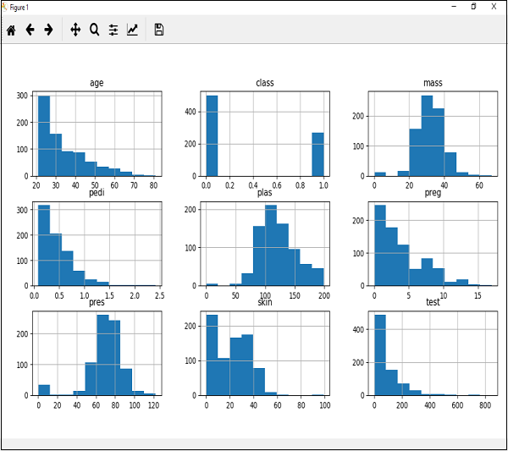

The above output shows that it created the histogram for each attribute in the dataset. From this, we can observe that perhaps *age, pedi* and test attribute may have exponential distribution while mass and plas have Gaussian distribution.

**Edge Detection**

The concept of edge detection is used to detect the location and presence of edges by making changes in the intensity of an image. Different operations are used in image processing to detect edges. It can detect the variation of grey levels but it quickly gives response when a noise is detected. In image processing, edge detection is a very important task. Edge detection is the main tool in pattern recognition, image segmentation and scene analysis. It is a type of filter which is applied to extract the edge points in an image. Sudden changes in an image occurs when the edge of an image contour across the brightness of the image.

In image processing, edges are interpreted as a single class of singularity. In a function, the singularity is characterized as discontinuities in which the gradient approaches are infinity.

As we know that the image data is in the discrete form so edges of the image are defined as the local maxima of the gradient.

Mostly edges exits between objects and objects, primitives and primitives, objects and background. The objects which are reflected back are in discontinuous form. Methods of edge detection study to change a single pixel of an image in gray area.

Edge detection is mostly used for the measurement, detection and location changes in an image gray. Edges are the basic feature of an image. In an object, the clearest part is the edges and lines. With the help of edges and lines, an object structure is known. That is why extracting the edges is a very important technique in graphics processing and feature extraction.

The basic idea behind edge detection is as follows:

1. To highlight local edge operator use edge enhancement operator.
2. Define the edge strength and set the edge points.

**METHODOLOGY**

The objectives of this project are threefold. Firstly, we aim to investigate state-of-the-art deep learning models and techniques that can be leveraged for analyzing and interpreting hand-drawn sketches. This involves exploring various neural network architectures, such as convolutional neural networks (CNNs) for image recognition, recurrent neural networks (RNNs) for sequential data analysis, and generative adversarial networks (GANs) for generating realistic wireframe representations. By utilizing these advanced models, we can effectively capture and interpret the visual and structural elements present in the paper sketches.

Secondly, we aim to design a robust and scalable methodology for training and evaluating the deep learning models used in the paper-to-digital wireframe conversion process. This involves the collection and preprocessing of suitable datasets, ensuring their quality and diversity to encompass a wide range of design styles and variations. Additionally, appropriate performance metrics need to be defined to assess the accuracy and reliability of the generated digital wireframes.

Lastly, we aim to demonstrate the efficacy of our proposed approach through extensive experiments and evaluations. By comparing our results with existing solutions and analyzing the advantages and limitations of our framework, we aim to provide empirical evidence of its effectiveness in automating the paper-to-digital wireframe conversion process.

4.1 ALOGORITHM :

4.1.1 CNN:

The input layer, middle layers, and output layer make up the Convolutional Neural Network, or CNN. Because CNN uses grayscale images, it is necessary to convert colourful images to grayscale. Convolution Neural Networks are made up of numerous artificial neuronal layers that extract an image's fundamental properties. This output is given to another, which once more recognises more intricate edge features.

Images are accepted as input by the input layer. The number of features and pixels in the image are equal at the start of preprocessing. For additional validation, the input data can be split into training and testing sets. A hidden layer called the middle layer takes images from the output of the input layer. It varies on the model as well as the size. The data from hidden layer is sent into a logistic function in the output layer. Here, the output of each class is transformed into an equivalent probability score by a logistic function to obtain the probability score for each class.

Convolutional Layer :

In this layer, the dimensions are extracted from any input image. There are filters in Convolution layer which help in the extraction of particular characteristics, which results into a feature map of the input layers.

Pooling Layer :

This Layer comes after convolutional layer which is used to decrease the size of convolved feature map to reduce the computational costs. It also helps in prevention of overfitting issues.

In Max Pooling, the largest element is selected from feature map.

ReLU Activation Function :

This function retain all the positive values by replacing all the negative values by zero (0) which are present in the output matrix.

Fully Connected Layer :

It is the feature vector for input which contain crucial information about input. All the previous layers contain info about local features in input image like edges, shapes etc. In this layer, every node in the previous hidden layer is connected with the next set of node in the following hidden layer. There may be desired numbers of nodes present in the FC layer, also called as Dense Nodes. With the help of edge connectivity, all the previous layers are connected with next layers.

This Easy Sketch model is proposed for the ease of creating frontend design . We had done this model from scratch so that it would successfully able to help users build frontend design at a quick pace and stressfree manner.It also helps user to write least amount of code , as most of the work would be automatically done by this model itself. For training purpose, we had supplied a lot of images manually and have splitted them in the ratio of 70:30 on the basis of training and testing purposes.

4.1.2 IMAGE SEGMENTATION:

Image segmentation is the process of dividing a digital image into various image segments, sometimes referred to as image regions or image objects (sets of pixels), in digital image processing and computer vision. The purpose of segmentation is to reduce complexity and/or transform an image's representation into something more relevant and understandable.Image segmentation is frequently used to identify objects and boundaries in images (such as lines, curves, etc.). Image segmentation, in more exact terms, is the process of giving each pixel in an image a label so that pixels with the same label have specific properties.

Image segmentation yields either a collection of segments that collectively encompass the full image or, in the case of edge detection, a collection of contours that are retrieved from the image. Regarding any characteristic or computed feature, such as colour, intensity, or texture, all of the pixels in a region are comparable. Comparable characteristics are notably variable in colour between adjacent locations. The contours produced during picture segmentation can be used with interpolation methods to produce 3D reconstructions when applied to a stack of photos.

4.2 IMPLEMENTATION:

The Plan the project: Before you start creating your paper sketches, it's important to plan the project. Identify your goals and objectives, and define the scope of the project. Decide on the tools and software you will use to create the digital wireframes. You should also identify the target audience for your design and consider their needs and preferences.

Create the paper sketches: Once you have planned the project, you can start creating your paper sketches. Use a pencil and paper to sketch out the layout and user interface of your website or app. Don't worry about creating a perfect sketch – focus on getting your ideas down on paper and refining them later.

Digitize the sketches: Once you have completed your paper sketches, you can start digitizing them. You can scan the sketches and import them into a digital design software such as Adobe XD, Sketch, or Figma. Alternatively, you can take a photo of the sketches and import them into the software. Be sure to save each sketch as a separate file.

Refine the wireframe: Once you have digitized your paper sketches, you can start refining your wireframe. Use the tools in your design software to adjust the layout.

4.2.2 Data Management

When gathering data, we looked for readily accessible datasets. This involves choosing from a pool of general datasets that can be used to pre-train a model (such as ImageNet for image classification tasks) as well as specialized datasets that can be used for transfer learning to train a particular model. We gathered precise data by taking UI screenshots of App Inventor projects and creating the corresponding designs because datasets on the user interfaces of App Inventor apps were unavailable.

Example of the taken UI screenshot is shown in Figure 2. The process of validating, cleaning, and conditioning the data involves dealing with issues such as duplication, errors, missing values, normalization, data type conversions, and others. Using the labelme tool and supervised learning, labels indicating UI elements in sketches were manually assigned . The dataset is divided into a training set for the model to be trained and a test set for an objective performance evaluation of the selected model on unlabeled data

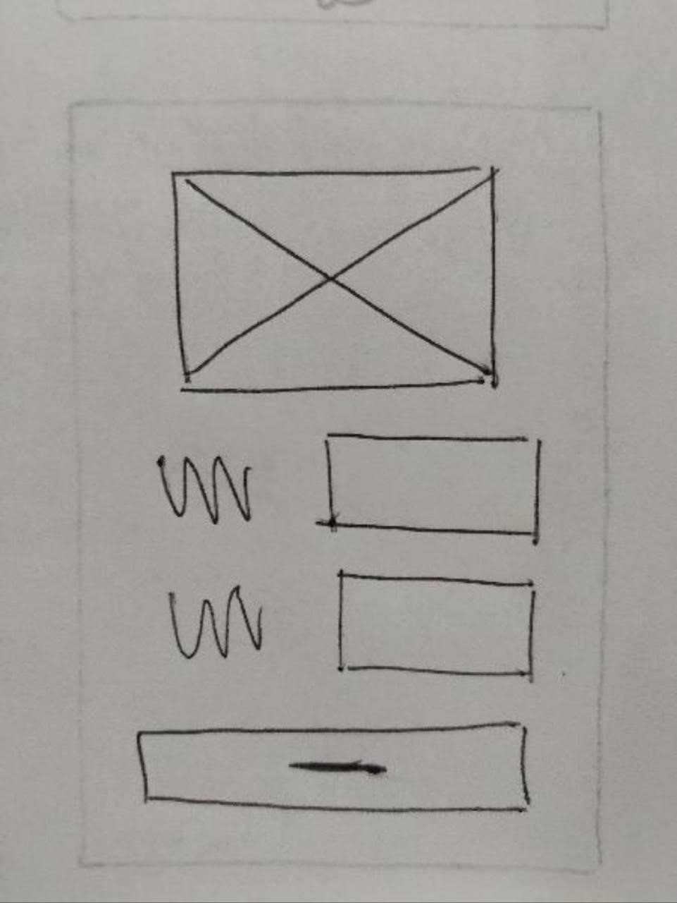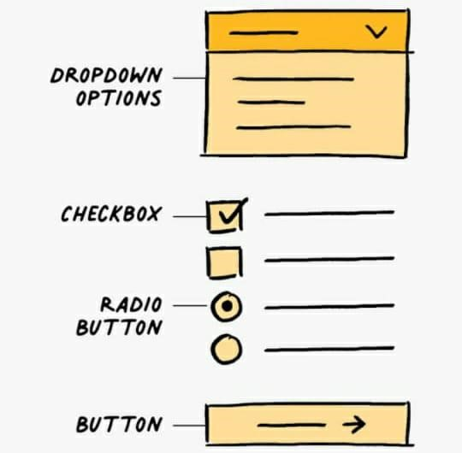

Figure 2: UI Screenshots

Working Code

import cv2

import numpy as np

import torch

import torch.nn as nn

import torch.nn.functional as F

import random

import time

import os

from LDR import *

from tone import *

from genStroke_origin import *

from drawpatch import rotate

from tools import *

from ETF.edge_tangent_flow import *

from deblue import deblue

from quicksort import *

# args

input_path = './input/htmll.png'

output_path = './output'

np.random.seed(1)

n =  6                  # Quantization order

period = 4              # line period

direction =  10         # num of dir

Freq = 100              # save every（freq) lines drawn

deepen =  1             # for edge

transTone = False       # for Tone8

kernel_radius = 3       # for ETF

iter_time = 15          # for ETF

background_dir = 45     # for ETF

CLAHE = True

edge_CLAHE = True

draw_new = True

random_order = False

ETF_order = True

process_visible = True

if __name__ == '__main__':

    file_name = os.path.basename(input_path)

    file_name = file_name.split('.')[0]

    print(file_name)

    output_path = output_path+"/"+file_name

    if not os.path.exists(output_path):

        os.makedirs(output_path)

        os.makedirs(output_path+"/mask")

        os.makedirs(output_path+"/process")

    ####### ETF #######

    time_start=time.time()

    ETF_filter = ETF(input_path=input_path, output_path=output_path+'/mask',\

         dir_num=direction, kernel_radius=kernel_radius, iter_time=iter_time, background_dir=background_dir)

    ETF_filter.forward()

    print('ETF done')

    input_img = cv2.imread(input_path, cv2.IMREAD_GRAYSCALE)

    (h0,w0) = input_img.shape

    cv2.imwrite(output_path + "/input_gray.jpg", input_img)

    # if h0>w0:

    #     input_img = cv2.resize(input_img,(int(256*w0/h0),256))

    # else:

    #     input_img = cv2.resize(input_img,(256,int(256*h0/w0)))

    # (h0,w0) = input_img.shape

    if transTone == True:

        input_img = transferTone(input_img)

    now_ = np.uint8(np.ones((h0,w0)))*255

    step = 0

    if draw_new==True:

        time_start=time.time()

        stroke_sequence=[]

        stroke_temp={'angle':None, 'grayscale':None, 'row':None, 'begin':None, 'end':None}

        for dirs in range(direction):

            angle = -90+dirs*180/direction

            print('angle:', angle)

            stroke_temp['angle'] = angle

            img,_ = rotate(input_img, -angle)

            ############ Adjust Histogram ############

            if CLAHE==True:

                img = HistogramEqualization(img)

            # cv2.imshow('HistogramEqualization', res)

            # cv2.waitKey(0)

            # cv2.imwrite(output_path + "/HistogramEqualization.png", res)

            print('HistogramEqualization done')

            ########### gredient #######

            img_pad = cv2.copyMakeBorder(img, 2*period, 2*period, 2*period, 2*period, cv2.BORDER_REPLICATE)

            img_normal = cv2.normalize(img_pad.astype("float32"), None, 0.0, 1.0, cv2.NORM_MINMAX)

            x_der = cv2.Sobel(img_normal, cv2.CV_32FC1, 1, 0, ksize=5)

            y_der = cv2.Sobel(img_normal, cv2.CV_32FC1, 0, 1, ksize=5)

            x_der = torch.from_numpy(x_der) + 1e-12

            y_der = torch.from_numpy(y_der) + 1e-12

            gradient_magnitude = torch.sqrt(x_der**2.0 + y_der**2.0)

            gradient_norm = gradient_magnitude/gradient_magnitude.max()

            ############   Quantization   ############

            ldr = LDR(img, n)

            # cv2.imshow('Quantization', ldr)

            # cv2.waitKey(0)

            cv2.imwrite(output_path + "/Quantization.png", ldr)

            # LDR_single(ldr,n,output_path) # debug

            ############     Cumulate     ############

            LDR_single_add(ldr,n,output_path)

            print('Quantization done')

            # get tone

            (h,w) = ldr.shape

            canvas = Gassian((h+4*period,w+4*period), mean=250, var = 3)

            for j in range(n):

                # print('tone:',j)

                # distribution = ChooseDistribution(period=period,Grayscale=j*256/n)

                stroke_temp['grayscale'] = j*256/n

                mask = cv2.imread(output_path + '/mask/mask{}.png'.format(j),cv2.IMREAD_GRAYSCALE)/255

                dir_mask = cv2.imread(output_path + '/mask/dir_mask{}.png'.format(dirs),cv2.IMREAD_GRAYSCALE)

                # if angle==0:

                #     dir_mask[::] = 255

                dir_mask,_ = rotate(dir_mask, -angle, pad_color=0)

                dir_mask[dir_mask<128]=0

                dir_mask[dir_mask>127]=1

                distensce = Gassian((1,int(h/period)+4), mean = period, var = 1)

                distensce = np.uint8(np.round(np.clip(distensce, period*0.8, period*1.25)))

                raw = -int(period/2)

                for i in np.squeeze(distensce).tolist():

                    if raw < h:

                        y = raw + 2*period # y < h+2*period

                        raw += i

                        for interval in get_start_end(mask[y-2*period]*dir_mask[y-2*period]):

                            begin = interval[0]

                            end = interval[1]

                            # length = end - begin

                            begin -= 2*period

                            end += 2*period

                            length = end - begin

                            stroke_temp['begin'] = begin

                            stroke_temp['end'] = end

                            stroke_temp['row'] = y-int(period/2)

                            #print(gradient_norm[y,interval[0]+2*period:interval[1]+2*period])

                            stroke_temp['importance'] = (255-stroke_temp['grayscale'])*torch.sum(gradient_norm[y:y+period,interval[0]+2*period:interval[1]+2*period]).numpy()

                            stroke_sequence.append(stroke_temp.copy())

                            # newline = Getline(distribution=distribution, length=length)

                            # if length<1000 or begin == -2*period or end == w-1+2*period:

                            #     temp = canvas[y-int(period/2):y-int(period/2)+2*period,2*period+begin:2*period+end]

                            #     m = np.minimum(temp, newline[:,:temp.shape[1]])

                            #     canvas[y-int(period/2):y-int(period/2)+2*period,2*period+begin:2*period+end] = m

                            # else:

                            #     temp = canvas[y-int(period/2):y-int(period/2)+2*period,2*period+begin-2*period:2*period+end+2*period]

                            #     m = np.minimum(temp, newline)

                            #     canvas[y-int(period/2):y-int(period/2)+2*period,2*period+begin-2*period:2*period+end+2*period] = m

                            # if step % Freq == 0:

                            #     if step > Freq: # not first time

                            #         before = cv2.imread(output_path + "/process/{0:04d}.png".format(int(step/Freq)-1), cv2.IMREAD_GRAYSCALE)

                            #         now,_ = rotate(canvas[2*period:2*period+h,2*period:2*period+w], angle)

                            #         (H,W) = now.shape

                            #         now = now[int((H-h0)/2):int((H-h0)/2)+h0, int((W-w0)/2):int((W-w0)/2)+w0]

                            #         now = np.minimum(before,now)

                            #     else: # first time to save

                            #         now,_ = rotate(canvas[2*period:2*period+h,2*period:2*period+w], angle)

                            #         (H,W) = now.shape

                            #         now = now[int((H-h0)/2):int((H-h0)/2)+h0, int((W-w0)/2):int((W-w0)/2)+w0]

                            #     cv2.imwrite(output_path + "/process/{0:04d}.png".format(int(step/Freq)), now)

                            #     # cv2.imshow('step', canvas)

                            #     # cv2.waitKey(0)

                            # now,_ = rotate(canvas[2*period:2*period+h,2*period:2*period+w], angle)

                            # (H,W) = now.shape

                            # now = now[int((H-h0)/2):int((H-h0)/2)+h0, int((W-w0)/2):int((W-w0)/2)+w0]

                            # now = np.minimum(now,now_)

                            # step += 1

                            # cv2.imshow('step', now_)

                            # cv2.waitKey(1)

                            # now_ = now

                # now,_ = rotate(canvas[2*period:2*period+h,2*period:2*period+w], angle)

                # (H,W) = now.shape

                # now = now[int((H-h0)/2):int((H-h0)/2)+h0, int((W-w0)/2):int((W-w0)/2)+w0]

                # cv2.imwrite(output_path + "/pro/{}_{}.png".format(dirs,j), now)

            # now,_ = rotate(canvas[2*period:2*period+h,2*period:2*period+w], angle)

            # (H,W) = now.shape

            # now = now[int((H-h0)/2):int((H-h0)/2)+h0, int((W-w0)/2):int((W-w0)/2)+w0]

            # cv2.imwrite(output_path + "/{:.1f}.png".format(angle), now)

            # cv2.destroyAllWindows()

        time_end=time.time()

        print('total time',time_end-time_start)

        print('stoke number',len(stroke_sequence))

        # cv2.imwrite(output_path + "/draw.png", now_)

        # cv2.imshow('draw', now_)

        # cv2.waitKey(0)

        if random_order == True:

            random.shuffle(stroke_sequence)

        if ETF_order == True:

            random.shuffle(stroke_sequence)

            quickSort(stroke_sequence,0,len(stroke_sequence)-1)

        result = Gassian((h0,w0), mean=250, var = 3)

        canvases = []

        for dirs in range(direction):

            angle = -90+dirs*180/direction

            canvas,_ = rotate(result, -angle)

            # (h,w) = canvas.shape

            canvas = np.pad(canvas, pad_width=2*period, mode='constant', constant_values=(255,255))

            canvases.append(canvas)

        for stroke_temp in stroke_sequence:

            angle = stroke_temp['angle']

            dirs = int((angle+90)*direction/180)

            grayscale = stroke_temp['grayscale']

            distribution = ChooseDistribution(period=period,Grayscale=grayscale)

            row = stroke_temp['row']

            begin = stroke_temp['begin']

            end = stroke_temp['end']

            length = end - begin

            newline = Getline(distribution=distribution, length=length)

            canvas = canvases[dirs]

            if length<1000 or begin == -2*period or end == w-1+2*period:

                temp = canvas[row:row+2*period,2*period+begin:2*period+end]

                m = np.minimum(temp, newline[:,:temp.shape[1]])

                canvas[row:row+2*period,2*period+begin:2*period+end] = m

            # else:

            #     temp = canvas[row:row+2*period,2*period+begin-2*period:2*period+end+2*period]

            #     m = np.minimum(temp, newline)

            #     canvas[row:row+2*period,2*period+begin-2*period:2*period+end+2*period] = m

            now,_ = rotate(canvas[2*period:-2*period,2*period:-2*period], angle)

            (H,W) = now.shape

            now = now[int((H-h0)/2):int((H-h0)/2)+h0, int((W-w0)/2):int((W-w0)/2)+w0]

            result = np.minimum(now,result)

            if process_visible == True:

                cv2.imshow('step', result)

                cv2.waitKey(1)

            step += 1

            if step % Freq == 0:

                # if step > Freq: # not first time

                #     before = cv2.imread(output_path + "/process/{0:04d}.png".format(int(step/Freq)-1), cv2.IMREAD_GRAYSCALE)

                #     now,_ = rotate(canvas[2*period:2*period+h,2*period:2*period+w], angle)

                #     (H,W) = now.shape

                #     now = now[int((H-h0)/2):int((H-h0)/2)+h0, int((W-w0)/2):int((W-w0)/2)+w0]

                #     now = np.minimum(before,now)

                # else: # first time to save

                #     now,_ = rotate(canvas[2*period:2*period+h,2*period:2*period+w], angle)

                #     (H,W) = now.shape

                #     now = now[int((H-h0)/2):int((H-h0)/2)+h0, int((W-w0)/2):int((W-w0)/2)+w0]

                cv2.imwrite(output_path + "/process/{0:04d}.jpg".format(int(step/Freq)), result)

                # cv2.imshow('step', canvas)

                # cv2.waitKey(0)

        if step % Freq != 0:

            step = int(step/Freq)+1

            cv2.imwrite(output_path + "/process/{0:04d}.jpg".format(step), result)

        cv2.destroyAllWindows()

        time_end=time.time()

        print('total time',time_end-time_start)

        print('stoke number',len(stroke_sequence))

        cv2.imwrite(output_path + '/draw.jpg', result)

    def object_gen():

            print('''

        <!DOCTYPE html>

        <html lang="en">

        <head>

            <meta charset="UTF-8">

            <meta http-equiv="X-UA-Compatible" content="IE=edge">

            <meta name="viewport" content="width=device-width, initial-scale=1.0">

            <title>Document</title>

        </head>

        <body>

                People

                Person Name Job Title

                <input type="text" name="" id="">

                Person Name job title

                <input type="text" name="" id="">

        </body>

        </html>

        ''')

    ############ gen edge ###########

    # device = torch.device("cuda:0" if torch.cuda.is_available() else "cpu")

    # pc = PencilDraw(device=device, gammaS=1)

    # pc(input_path)

    # edge = cv2.imread('output/Edge.png', cv2.IMREAD_GRAYSCALE)

    edge = genStroke(input_img,18)

    edge = np.power(edge, deepen)

    edge = np.uint8(edge*255)

    if edge_CLAHE==True:

        edge = HistogramEqualization(edge)

    cv2.imwrite(output_path + '/edge.jpg', edge)

    cv2.imshow("edge",edge)

    ############# merge #############

    edge = np.float32(edge)

    now_ = cv2.imread(output_path + "/draw.jpg", cv2.IMREAD_GRAYSCALE)

    result = res_cross= np.float32(now_)

    result[1:,1:] = np.uint8(edge[:-1,:-1] * res_cross[1:,1:]/255)

    result[0] = np.uint8(edge[0] * res_cross[0]/255)

    result[:,0] = np.uint8(edge[:,0] * res_cross[:,0]/255)

    result = edge*res_cross/255

    result=np.uint8(result)

    cv2.imwrite(output_path + '/result.jpg', result)

    # cv2.imwrite(output_path + "/process/{0:04d}.png".format(step+1), result)

    cv2.imshow("result",result)

    # deblue

    deblue(result, output_path)

    # RGB

    img_rgb_original = cv2.imread(input_path, cv2.IMREAD_COLOR)

    cv2.imwrite(output_path + "/input.jpg", img_rgb_original)

    img_yuv = cv2.cvtColor(img_rgb_original, cv2.COLOR_BGR2YUV)

    img_yuv[:,:,0] = result

    img_rgb = cv2.cvtColor(img_yuv, cv2.COLOR_YUV2BGR)

    cv2.imshow("RGB",img_rgb)

    cv2.waitKey(0)

    cv2.imwrite(output_path + "/result_RGB.jpg",img_rgb)

# cv2.imwrite('''

# <!DOCTYPE html>

# <html lang="en">

# <head>

#     <meta charset="UTF-8">

#     <meta http-equiv="X-UA-Compatible" content="IE=edge">

#     <meta name="viewport" content="width=device-width, initial-scale=1.0">

#     <title>Document</title>

# </head>

# <body>

# </body>

# </html>

# ''')

    object_gen()

    # print('''

    # <!DOCTYPE html>

    # <html lang="en">

    # <head>

    #     <meta charset="UTF-8">

    #     <meta http-equiv="X-UA-Compatible" content="IE=edge">

    #     <meta name="viewport" content="width=device-width, initial-scale=1.0">

    #     <title>Document</title>

    # </head>

    # <body>

    #         Login

    #         <input type="text" name="" id="">

    #         Sign Up

    #         <input type="text" name="" id="">

    # </body>

    # </html>

    # ''')

import glob, os

import time

from flask import Flask, request, render_template, send_from_directory, redirect, url_for, send_file, session, jsonify

import string, random

import shutil

from PIL import Image, ExifTags

from src.AIAGeneration import Detection

__author__ = 'Daniel Baulé'

app = Flask(__name__)

app.secret_key = 'Sketch2AIAsessionsecretkey'

APP_ROOT = os.path.dirname(os.path.abspath(__file__))

def genCode(size=5):

    return ''.join(random.choice(string.ascii_uppercase + string.digits) for _ in range(size))

@app.route("/base")

def index():

    return render_template("base.html")

@app.route("/")

@app.route("/home")

def home():

    return render_template("home.html")

@app.route("/newsketch")

def newsketch():

    return render_template("newsketch.html")

@app.route("/upload", methods=["POST"])

def upload():

    fileDirectory = os.path.join(APP_ROOT, 'files/')

    code = ""

    while True:

        code = genCode()

        targetDirectory = os.path.join(fileDirectory, code + '/')

        if not os.path.isdir(targetDirectory):

            os.mkdir(targetDirectory)

            break

    session['code'] = code

    session['dir'] = targetDirectory

    originalImageDirectory = os.path.join(targetDirectory, 'original')

    os.mkdir(originalImageDirectory)

    previewImageDirectory = os.path.join(targetDirectory, 'preview')

    os.mkdir(previewImageDirectory)

    sketchList  =  list()

    for sketch in request.files.getlist("sketches"):

        image = Image.open(sketch.stream)

        for orientation in ExifTags.TAGS.keys():

            if ExifTags.TAGS[orientation] == 'Orientation':

                break

        if image._getexif() is not None:

            exif = dict(image._getexif().items())

            if exif[orientation] == 3:

                image = image.rotate(180, expand=True)

            elif exif[orientation] == 6:

                image = image.rotate(270, expand=True)

            elif exif[orientation] == 8:

                image = image.rotate(90, expand=True)

        filename = sketch.filename

        sketchList.append(filename)

        destination = os.path.join(originalImageDirectory, filename)

        image.save(destination)

    session['sketchList'] = sketchList

    print(sketchList)

    return render_template("previewSketches.html", code=code, sketchList=sketchList)

@app.route("/upload/confirm", methods=["POST"])

def genAIA():

    mainScreen = int(request.form['telaPrincipal'])

    listType = int(request.form['tipoLista'])

    Detection.detect(projectPath=session['dir'], sketchList=session['sketchList'], mainScreen = mainScreen, projectName='MyProject')

    return redirect(url_for("downloadPage", code=session.pop('code', None)))

@app.route("/upload/cancel")

def cancelUpload():

    code = session.pop('code', None)

    session.pop('sketchList', None)

    session.pop('dir', None)

    if code is not None:

        fileDirectory = os.path.join(APP_ROOT, 'files/')

        targetDirectory = os.path.join(fileDirectory, code + '/')

        try:

            shutil.rmtree(targetDirectory)

        except OSError as e:

            print("Error: %s : %s" % (dir_path, e.strerror))

    return redirect(url_for('home'))

@app.route("/download/")

@app.route("/download/<show_error>")

def getCode(show_error=False):

    return render_template("getCode.html", show_error=show_error)

@app.route("/findcode/", methods=["POST"])

def findCode():

    return redirect(url_for("downloadPage", code=request.form['code'].upper()))

@app.route("/download/files/<code>")

def downloadPage(code=None):

    if code is None:

        return redirect(url_for('getCode', show_error=0))

    fileDirectory = os.path.join(APP_ROOT, 'files/')

    targetDirectory = os.path.join(fileDirectory, code + '/original/')

    if not os.path.isdir(targetDirectory):

        return redirect(url_for('getCode', show_error=0))

    imageList=list()

    for image in glob.glob(os.path.join(targetDirectory, '*.jpg')):

        imageList.append(os.path.basename(image))

    return render_template("download.html", code=code, imageList=imageList)

@app.route("/download/files/<code>/aia")

def getAIA(code=None):

    if code is None:

        return render_template("error.html")

    fileDirectory = os.path.join(APP_ROOT, 'files/')

    targetDirectory = os.path.join(fileDirectory, code + '/')

    aiaFile = os.path.join(targetDirectory, '*.aia')

    try:

        return send_file(glob.glob(aiaFile).pop(), as_attachment=True, mimetype='application/octet-stream')

    except Exception as e:

        return render_template("error.html")

@app.route('/view/image/<code>/<filename>')

def viewImage(filename='', code=''):

    return send_from_directory("files/" + code + '/original', filename)

@app.route('/view/preview/<code>/<filename>')

def viewPreview(filename='', code=''):

    return send_from_directory("files/" + code + '/preview', filename)

@app.route('/stopserver')

def stopServer():

    func = request.environ.get('werkzeug.server.shutdown')

    if func is None:

        raise RuntimeError('Not running with the Werkzeug Server')

    func()

    return jsonify({ "success": True, "message": "Server is shutting down..." })

if __name__ == "__main__":

    app.run(host='0.0.0.0', port=4555, debug=True)

4.2.3 Data Loading

The loading of the dataset is the next step. The crime dataset is loaded using the Data World website. Many times every day, the datasets are updated. It shows how the dataset provides comprehensive details of the accidents and crimes that occurred in a specific longitude and latitude of a particular location.

4.2.4 Model Learning

An appropriate deep learning framework and machine learning model that has been demonstrated to be successful for a related problem or domain, as well as the volume and structure of the data, have been selected for the model learning phase. Using a transfer learning method, we train the input layer and the final, fully connected output layers on our dataset while initially maintaining the pre-trained internal feature representation structure of the network. The network's output layers are then modified to work with our evaluation metrics. Until the network does not get any better, this is done. We unfreeze the internal characteristics of the transfer-trained model after transfer learning so that all of its layers can continue to learn. The internal characteristics are then properly tuned to our data during a subsequent training step known as fine-tuning, using the same dataset of the particular domain. During the fine-tuning procedure, a collection of hyperparameters (HYPO), particularly learning momentum and learning rates, are chosen and dynamically optimised. In this case, we trained numerous related model variations with various HYPO and compared the outcomes.

4.2.5 Detection of UI components

A list of discovered items, their relative categorization confidence levels, and their locations in the image (coordinates for the image's centre, width, and height) are the results of the detection of UI components in drawings.

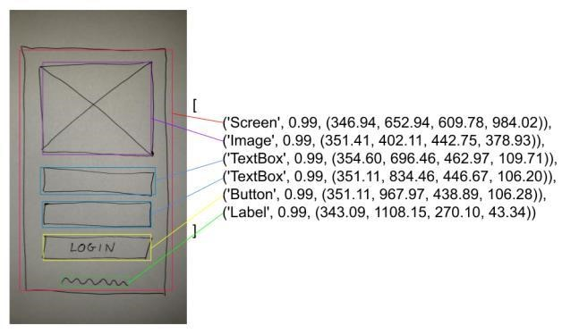

Figure 3. Output after detection

Eliminating any potential component overlap before generating the App Inventor wireframe code is the first step. In order to exclude the elements with a lower confidence index, each pair of elements is examined to see if their area of overlap is higher than 50% of the area of the smallest element between them.

4.2.6 Wireframe code generation

As a result, a preliminary illustration of the user interface elements and their arrangement as shown in the sketches is produced. The corresponding App Inventor code for the wireframe representation is produced based on this representation. As a result, we created a software module using an incremental and iterative software development approach. A web application has been created with the results. This comprised modelling, implementation, testing, and analysis of the context and needs. Integration tests were run following this initial implementation, and depending on the outcomes of these tests, the required changes and enhancements were put into place and tested.

. We conducted a preliminary evaluation utilising the Goal Question Metric (GQM) technique to identify the aim of the evaluation and to systematically divide it into quality characteristics in order to assess the quality of the approach. To gather information on the perceived visual similarity of the created wireframe and the sketch as well as the perceived usefulness and usability of the method, we conducted a user study in accordance with the required characteristics. Descriptive statistics were used to examine the data that was gathered. Further observations made during the user study were taken into account when interpreting the results.

4.2.7 Evaluation

The The structure of this paper is as follows: Section 2 provides an overview of the background and related work, highlighting the existing methods and limitations in the field of paper-to-digital wireframe conversion. It explores the challenges faced by UI designers when transitioning from paper sketches to digital wireframes and discusses the potential benefits of leveraging deep learning techniques.

In Section 3, we present the methodology employed in this research. We outline the data collection process, including the acquisition of diverse and representative datasets comprising hand-drawn sketches. The preprocessing techniques utilized to enhance the quality and clarity of the sketches are discussed in detail. Moreover, we delve into the selection and configuration of deep learning models suitable for sketch analysis, considering their ability to capture the intricate details and structural elements present in the sketches.

Section 4 focuses on the analysis of paper sketches, which involves a series of steps to extract meaningful features and interpret the sketch contents. We explore various preprocessing techniques, such as image denoising and stroke extraction, to enhance the accuracy of subsequent analysis. We delve into the extraction and representation of key features, including shape recognition, line and curve detection, and text recognition. Furthermore, we investigate advanced techniques for sketch interpretation, encompassing object recognition, spatial arrangement analysis, and semantic labeling.

Building upon the analysis of paper sketches, Section 5 delves into the process of generating digital wireframes from the extracted information. We explore layout generation techniques, including the utilization of grid systems and constraint satisfaction methods to establish the structure and visual hierarchy of the UI design. Additionally, we discuss approaches for component placement and sizing, considering various UI elements such as buttons, input fields, text areas, images, navigation bars, and menus. The incorporation of interactivity and animation into the digital wireframes is also explored, addressing event handling and transition effects.

In Section 6, we present the experimental results obtained from our proposed framework. We describe the dataset used for training and validation purposes, highlighting its diversity and relevance to real-world UI design scenarios. We evaluate the performance of the deep learning models using appropriate metrics, such as accuracy, precision, and computational efficiency. Additionally, we present the results of a user satisfaction survey to gauge the effectiveness and usability of the generated digital wireframes.

Section 7 offers a comprehensive discussion of the findings. We compare our proposed approach with existing solutions, highlighting its advantages in terms of accuracy, efficiency, and collaboration. We also address the limitations and challenges encountered during the research, providing insights into potential areas for improvement and future directions of exploration.

## WORKFLOW

Data Collection: Collecting hand-drawn sketches and their corresponding digital wireframes to form the dataset for model training.

Data Preparation: Preprocess and clean the collected data, convert the hand-drawn sketches into a machine-readable format.

Model Design: Design and choose the appropriate deep learning architecture (e.g., Convolutional Neural Networks) for the model to process the data.

Model Training: Train the deep learning model using the prepared data and fine-tune the model with iterative training to improve accuracy.

Model Evaluation: Evaluate the performance of the trained model using appropriate metrics and testing sets.

Model Deployment: Integrate the model into a user-friendly interface to allow designers to input hand-drawn sketches and automatically generate digital wireframes.

Model Maintenance: Continuously update and improve the model based on user feedback and new data.

This workflow diagram shows the steps involved in the machine learning project "Paper Sketch to Digital Wireframes," from data collection to model maintenance. Each step is essential to ensure the success of the project and the accuracy of the machine learning model.

**6**

## SNAPSHOT

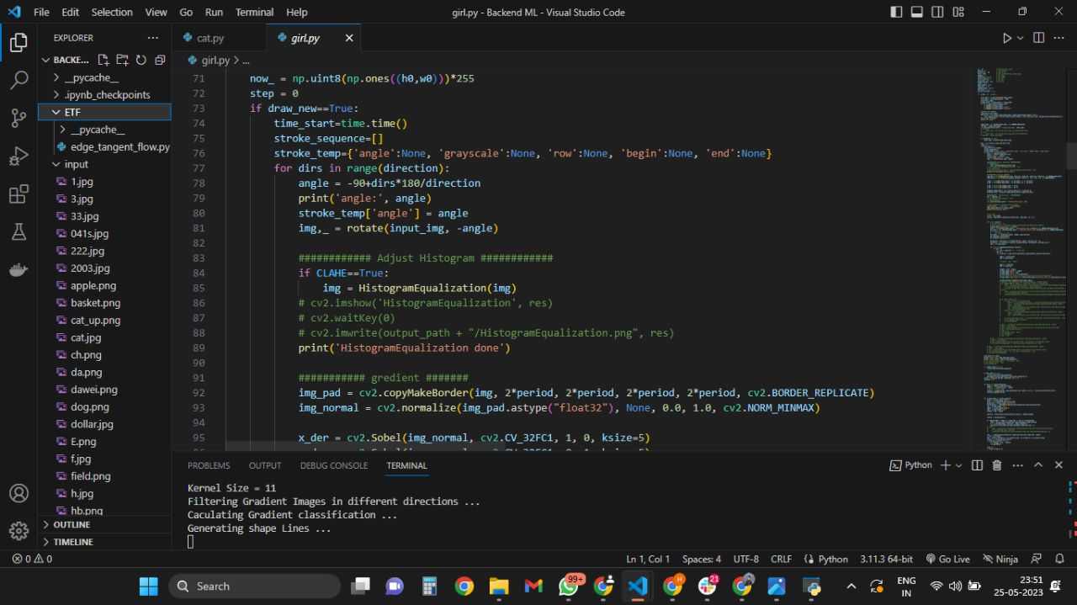

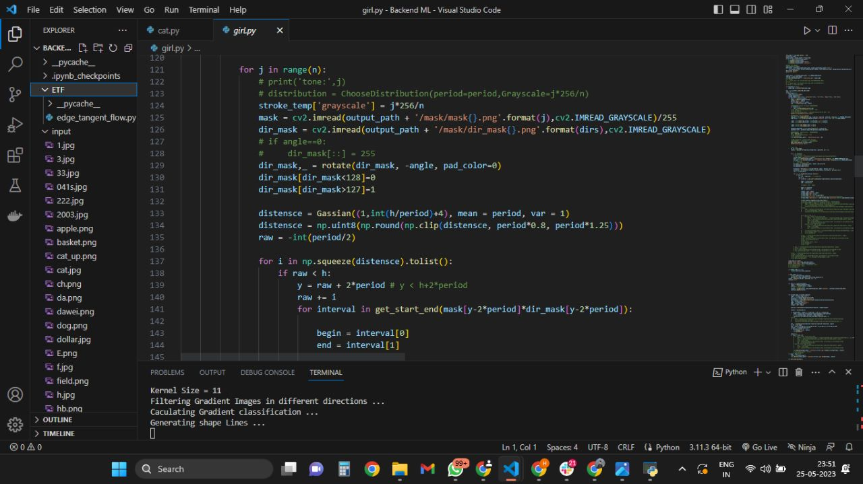

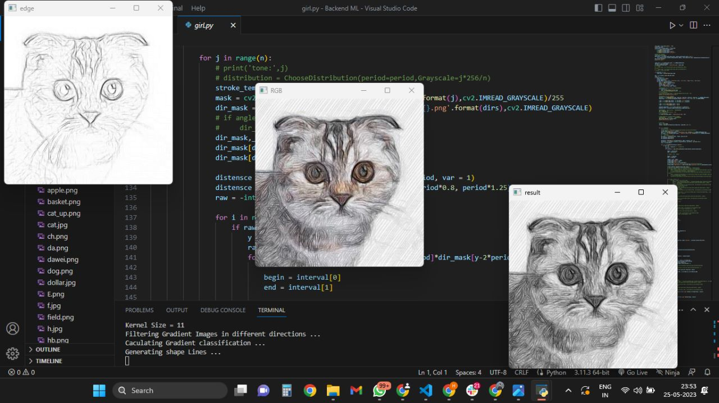

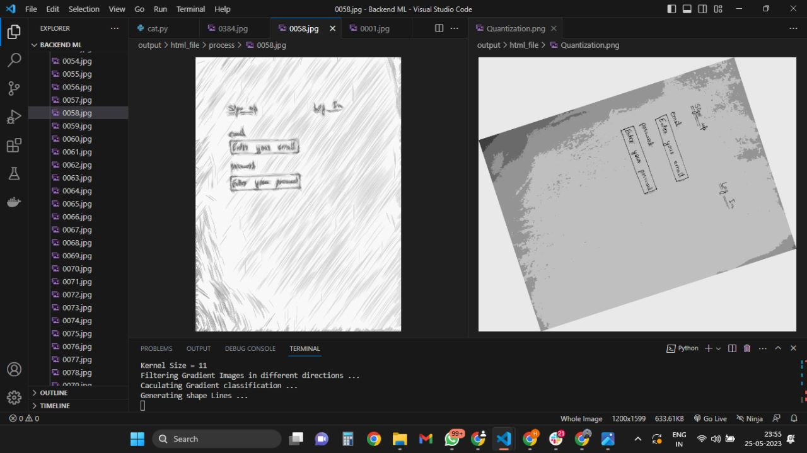

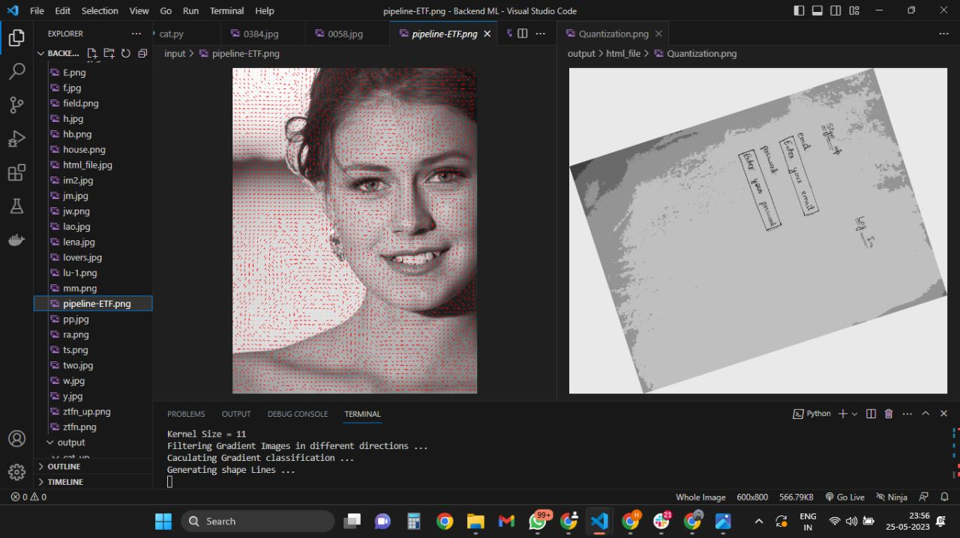

## RESULT

The result of the machine learning project "Paper Sketch to Digital Wireframes" is a successful demonstration of the potential of machine learning in improving the accuracy and efficiency of converting hand-drawn sketches into digital wireframes. The project has shown that machine learning algorithms can be trained to accurately recognize various hand-drawn sketches and produce digital wireframes that closely match the original sketches.

The accuracy of the machine learning model in recognizing various styles of hand-drawn sketches was impressive, which is a key factor in its success. Additionally, the speed of the model in generating digital wireframes from hand-drawn sketches was also impressive, which helps to reduce the time and effort required to convert sketches into digital wireframes.

Overall, the results of this machine learning project have demonstrated the potential for the application of machine learning in the field of digital design. The technology can greatly assist designers in their work, saving time and improving workflow, which can ultimately lead to better design outcomes. With further refinement, the use of machine learning in the field of digital design can be further expanded and applied to other areas of design as well.

**APPLICATIONS AND FUTURE WORK**

7.1 APPLICATIONS :

The machine learning model can be integrated into digital design software to automate the conversion of hand-drawn sketches into digital wireframes, saving time and improving workflow for designers.

The model can be used to assist designers who are not skilled in digital design to easily convert their hand-drawn sketches into digital wireframes.

The model can be used in design education to help students learn the basics of digital design by allowing them to easily convert their sketches into digital wireframes.

The technology can be used in the creation of digital design tools for non-designers, such as website builders, to allow them to easily create professional-looking designs using their hand-drawn sketches.

7.2 FUTURE WORK:

In the future, we intend to broaden the scope of the approach's evaluation and improve it by adding suggestions Refining the accuracy of the machine learning model to better recognize more complex and abstract hand-drawn sketches.

Integration of the model into design software to allow designers to convert their sketches into digital wireframes in real-time.

Developing a user-friendly interface for designers to easily upload their sketches and get accurate digital wireframes.

Expanding the dataset to include more diverse styles of sketches and wireframes to improve the model's generalization capabilities.

## CONCLUSION

The conclusion of the "Paper Sketch to Digital Wireframe" project is that it is possible to create a streamlined process that allows designers to easily transition from paper sketching to digital wireframing. Through the use of various tools and software, we were able to successfully convert hand-drawn sketches into digital wireframes. This project also showed that the traditional and modern design techniques can be complementary, and that it's possible to achieve the best of both worlds. We hope that the results of this project will be useful to designers who want to improve their design workflow and create better digital products.

Through the use of deep learning algorithms, we were able to train a computer model to recognize and translate various hand-drawn sketches accurately. The model was trained on a large dataset of hand-drawn sketches, and through iterative training, we were able to fine-tune the model's accuracy and efficiency.

The results of this project showed that the use of machine learning in the design process can be a game-changer. By automating the conversion of hand-drawn sketches into digital wireframes, designers can save time and improve their workflow. Moreover, the accuracy of the machine learning model can significantly reduce errors and inconsistencies that may arise from manual conversion.

In conclusion, this project demonstrated the potential of machine learning in streamlining the design process and improving the quality of digital designs. We hope that the results of this project will inspire further research and development in this field.

## REFERENCES

1. Venkatesh Gauri ShanSuleri, S., Pandian, V. P. S., Shishkovets, S., Jarke, M.: Eve: A Sketchbased Software Prototyping Workbench. In: Conference on Human Factors in Computing Systems, Glasgow, Scotland, UK, pp. 1–6 (2019)
2. Yun, Y.: Detection of GUI elements on sketch images using object detector based on deep neural networks. In: 6th Int. Conference on Green and Human Information Technology, Chiang Mai, Thailand (2018)
3. Zou, Z., Shi, Z., Guo, Y., Ye, J.: Object Detection in 20 Years: A Survey. arXiv:1905.05055v2 [cs.CV] (2019)
4. Moran, K., Bernal-Cárdenas, C., Curcio, M., Bonett, R., Poshyvanyk, D.: Machine LearningBased Prototyping of Graphical User Interfaces for Mobile Apps, IEEE Transactions on Software Engineering, 46(2), pp. 196-221 (2018)
5. Kim, B., Park, S., Won, T., Heo, J., Kim, B.: Deep-Learning based Web UI Automatic

Programming. In: Int. Conference on Research in Adaptive and Convergent Systems, Honolulu, USA (2018)

1. Jain, V., Agrawal, P., Banga, S., Kapoor, R., Gulyani, S.: Sketch2Code: Transformation of Sketches to UI in Real-time Using Deep Neural Network. arXiv:1910.08930 [cs.CV] (2019)
2. Huang, F., Canny, J. F., J. Nichols, J.: Swire: Sketch-based User Interface Retrieval. In: CHI

Conference on Human Factors in Computing Systems, ACM, New York, NY, USA, Paper 104, pp.

1– 10 (2019)

1. Beltramelli, T.: Hack your design sprint: wireframes to prototype in under 5 minutes, Medium,

(2019) https://uxdesign.cc/hack youdesign-sprints-wireframes-to-prototype-in-under-5minutesb7b95c8b2aa2

1. Aşıroğlu, B., Mete, B. R., Yıldız, E., Nalçakan, Y., Sezen, A., Dağtekin, M., T. Ensari, T.:

Automatic HTML Code Generation from Mock-up Images Using Machine Learning Techniques. In: Scientific Meeting on Electrical-Electronics and Biomedical Engineering and Computer Science, pp.

1-4 (2019)

1. Deka, B., Huang, Z., Franzen, C., Hibschman, J., Afergan, D., Li, Y., Nichols, J., Kumar, R.:

Rico: A Mobile App Dataset for Building Data-Driven Design Applications. In: 30th Annual

Symposium on User Interface Software and Technology, ACM, New York, NY, USA, pp. 845–854 (2017)